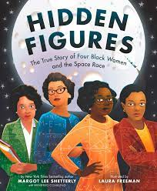

**Revisited Skills:**

* I can structure my writing clearly and coherently
* I can use a range of sentence types including simple, compound, and complex sentences
* I can use a range of conjunctions to link facts
* I can use a range of (fronted) adverbials
* I can use a range of adjectives
* I can use relative clauses
* I can accurately use capital letters and full stops

**New Skills:**

* I can use a range of suffixes
* I can use prefixes ‘un’ and ‘in’
* I can use subordinate clauses to link ideas
* I can use relative clauses
* I can edit and redraft for cohesive devices.
* I can check and edit my work

**Audience:** Future aspiring NASA scientists and engineers.

**Form:** To create a memoir of Katherine Johnson or Mary Jackson

**Purpose:** To inform the reader about the life and achievements of Katherine Johnson or Mary Jackson

**Theme:** Ambition and Desire

**Related texts:**

[Fantastically Great Women: True Stories of Ambition, Adventure and Bravery](https://www.lovereading4kids.co.uk/book/9781526623607/isbn/Fantastically-Great-Women-True-Stories-of-Ambition-Adventure-and-Bravery-by-Kate-Pankhurst.html) - [Kate Pankhurst](https://www.lovereading4kids.co.uk/author/2450/Kate-Pankhurst.html)

The Story of Ruby Bridges – Robert Coles

**Tier 3 Vocabulary:**

Aeronautics Cosmonaut

Segregated Unconstitutional

Sputnik

Congress

Trajectories

Supersonic

**Tier 2 Vocabulary:**

Advisory Equality

Assignments Perseverance

Competing

Engineer

Laboratory

Satellite