Year 3 – RE- Creation- Christianity- Golden Thread Love
What should I already know? | What am I going to learn in this unit? | Vocabulary I need to know
Knowledge  - Know how ‘Imagery’ might feature in the Christian story of creation.  - Awareness of the concept of ‘The Cycle of Life’ (year 1).  - Awareness of the concept of ‘New Beginnings’ (year R).  Skills  - I can give examples of how a concept is seen within a religion.  - I can realise that some ideas are hard to explain.  - I can reflect on important issues and talk about my feelings. | Inquire  - I can describe clearly, in simple terms, the meaning of the concept of creation.  - I can begin to express ideas about how and why things are created.  Contextualise  - I can retell the key parts of the Christian story of creation.  - I can begin to identify why the Christian creation story is important to believers.  Evaluate  - I can say whether I agree or disagree with all or some parts of the Christian story of creation.  - I can express my view on the creation of the world and/or living things.  Communicate  - I can record my understanding of how the world came to be  - I can express whether an understanding of creation is important to me and why I think creation stories are important to others.  Apply  - I can describe simple examples of how responses to the concept of creation relates to my own life and the lives of others.  - I can identify some differences the concept makes to the lives of religious people and myself. | Sin 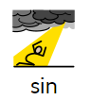 To do something that breaks a religious law or is felt to be bad. .  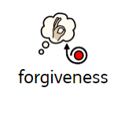 Forgiveness The action or process of forgiving or being forgiven.  Universe The universe is everything we can touch, feel, sense, measure and detect. It includes living things, plants, stars, dust and clouds.  Creation 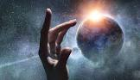 The action or process of bringing something into existence. crucifixion.  Light and Darkness 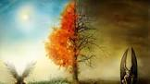 Darkness is the absent of light and shadows. Light is a form of energy that allows us to see the world around us.

