Year 5 – French – En classe
What should I already know? | What am I going to learn in this unit? | Vocabulary I need to know
- I can listen to someone speaking French and understand them  - I know the vocabulary from the Early learning units  - I can say ‘Hello’ in French  - I can ask and answer questions about myself, (How are you? What is your name? How old are you? Where do you live?)  - I can talk, read and write about pets and listen to and understand others talking about pets in French  - I can count to twenty in French | - I can recall 12 classroom objects and their determiners in French  - I can use possessive pronouns (for my) to replace determiners in French  - I can say which classroom objects I do have in French  - I can say which classroom objects I do not have in French  - I can read and recognise the nouns for classroom objects in French  - I can write simple phrases and sentences about classroom objects in French  - I can use simple connectives (‘et’) in my speech in French | 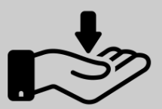  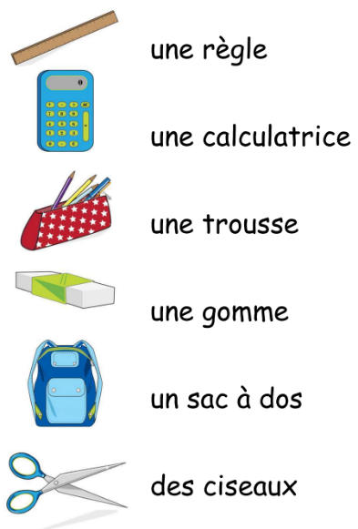  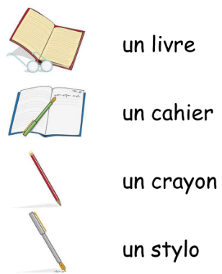  J’ai un/une/des – I have a/some  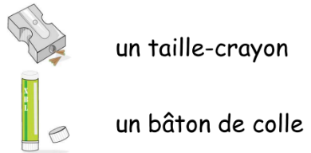  Je n’ai pas de – I do not have  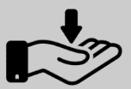  Dans ma trousse j’ai …  