Year 6 – Geography – Globalisation and trade.
What should I already know? | What am I going to learn in this unit? | Vocabulary I need to know
- explain the interior of the earth – explaining the mantle, crust and core.  - research an earthquake and be able to talk about the impact it had on the area it hit.  - discuss the prevention and detection methods that are used to minimise the risk of an earthquake.  - Explain the secondary effects of an earthquake.  - Name at least 3 countries in North America  - Know where the Greenwich meridian is on a map  - Explain the time zones across the globe and work out the difference in time. | - I know that globalisation is the world becoming more connected for different purposes through local, national and international trade.  - I know what types of transport have been important to globalisation and describe how this has changed over time for local national and international trading.  - I can explain what trade was like in the past for local national and international trading.  - I can explain how trade has changed over the years.  - I know some advantages and disadvantages of trading.  - I know what fast fashion is.  - I know that everyday clothes I wear come from all over the world and can give examples of this.  - I know what a multi-national company is and the advantages and disadvantages are of these.  - I know where the food I eat comes from and why this is imported and not home grown. | Globalisation 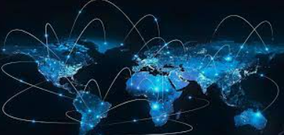 Is the way that things are done around the world together. This includes economics, trade, technology, politics or culture.  Trade 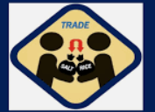 The buying or selling of goods and services.  Local 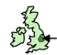 Within a small area or region, usually a part of a country.  National 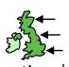 Within a country.  International 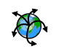 All around the world.  Port 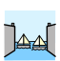 Place where boats can come and go to load and unload their supplies or people.  Container 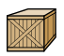 A metal box that is used to transport goods all around the globe.

