Year 6 Science – Light – Autumn 2
What should I already know? | What am I going to learn in this unit? | Vocabulary I need to know
- Explore how things work  - Identify, name, draw and label the basic parts of the human body and say which part of the body is associated with each sense  - Recognise that I need light in order to see things and that dark is the absence of light  - Notice that light is reflected from surfaces  - Recognise that shadows are formed when the light from a light source is blocked by an opaque object  - Find patterns in the way that the size of shadows change  - Compare and group together everyday materials on the basis of their properties, including their hardness, solubility, transparency, conductivity (electrical and thermal), and response to magnets  - I can ask scientific questions independently  - I can select a range of practical resources to gather evidence to answer my questions  - I can select measuring equipment to give the most precise results  - I can decide how to record and present evidence | - I can recognise that light appears to travel in straight lines  - I can use the idea that light travels in straight lines to explain that objects are seen because they give out or reflect light into the eye  - I can explain that we see things because light travels from light sources to our eyes or from light sources to objects and then to our eyes  - I can use the idea that light travels in straight lines to explain why shadows have the same shape as the objects that cast them  - I can ask scientific questions independently  - I can select a range of practical resources to gather evidence to answer my questions  - I can select measuring equipment to give the most precise results  - I can decide how to record and present evidence | Reflection  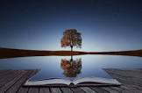 | The throwing back by a body or surface of light, head or sound without absorbing it
 |  | Refraction  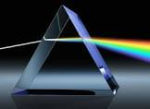 | The bending of light as it passes from one substance to another with the bending cause by the difference in density between two substances
 |  | Shadow  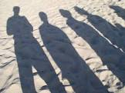 | A dark area or shape produced by a body coming between rays of light and a surface
 |  | Spectrum | A band of colours, as seen in rainbows, produced by separation of the components of light by their different degrees of refraction
 |  | Light source  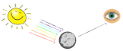 | Something that provides light, whether it be a natural or artificial source of light (e.g. the sun or torch)
 |  | Periscope  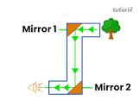 | An apparatus consisting of a tube attached to a set of mirrors or prisms through which an observer can see things that are otherwise out of sight

