Year 6 – French – Le Weekend
What should I already know? | What am I going to learn in this unit? | Vocabulary I need to know
- I can give personal details from memory (name, age and where I live) in French  - I can use letter sounds (phonics and phonemes) in French  - I can apply language learned in previous topics in French | - I can tell the time in French, using quarter past, half past and quarter to  - I can talk about what I do at the weekend using two or more sentences in French  - I can integrate conjunctions and opinions into written and spoken work to make more interesting and extended sentences in French  - I can read and write simple sentences about the weekend in French | 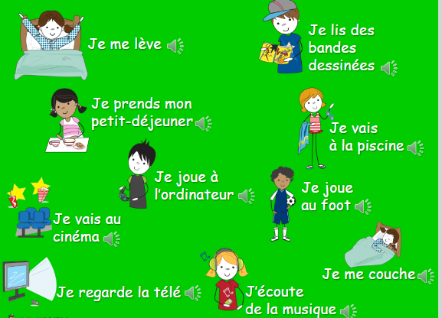  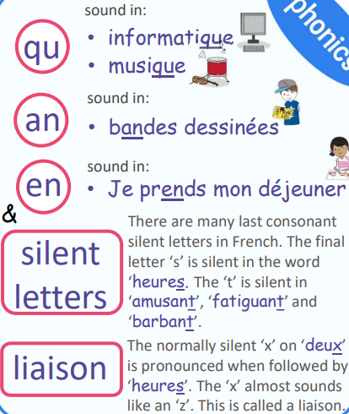  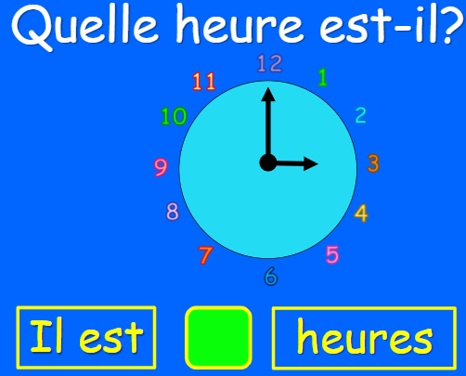  Il est une heure. – It is one o’clock.  Il est trois heures. - It is three o’clock.  Il est quatre heures. – It is four o’clock.  Il est cinq heures. - It is five o’clock.  … dix - ten past  …vingt-cinq - twenty five past  …et demie - half past

