Year 6 Musical Modes: Autumn Two
What should I already know? | What I am learning | Key Vocabulary
- I understand the importance of music during war and its many purposes.  - I can make thoughtful comments about a piece of music using musical terminology.  - I understand how tempo and keeping the beat was crucial to soldiers.  - I can identify instruments used in a piece of music and understand their purpose and effect.  - I can sing in parts and rounds with growing confidence and accuracy.  - I can create an effective accompaniment to a song using tuned instruments.  - I can play a part in an ensemble performance, rehearse and make improvements. | - I can recognise work songs and understand the purposes of them.  - I know the difference between major, minor scales and modes and how each are used.  - I can identify some medieval instruments.  - I understand how modes were used in the Medieval and Tudor periods and are still used in music of today.  - I can sing a medieval song in Latin.  - I can play melodies on tuned instruments and accompany with chords in an ensemble performance.  - I can improvise over a groove in a major and a modal key.  - I can compose my own piece in the Dorian mode. | Dorian Mode | A mode using the white notes of the keyboard from D - D
 |  | Improvise | Making melodies up as you go along following the notes of the scale or mode
 |  | Drone | Two notes (first and fifth of the scale) played together as an accompaniment to a melody
 |  | Work song  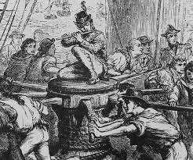 | A song used by workers to keep in time with each other – sea shanties, waulking songs
 |  | 