Year 6 Computing Autumn 2
What should I already know? | What am I going to learn in this unit? | Vocabulary I need to know
Digital Literacy:  - I can participate in a class discussion  - I can contribute to a class discussion to create e – safety rules  - I know how to use technology safely  - I know what acceptable and unacceptable behaviour means  - I know what acceptable and unacceptable behaviour is when using technology  - I know what inappropriate behaviour looks like in a variety of contexts  - I know who to report concerns and inappropriate behaviour to a variety of contexts  - I know how to report concerns and inappropriate behaviour in a variety of contexts  - I know who my trusted adults are in school and outside of school  Information Technology:  - I know what a network is  - I know and can explain how a network works  - I know how the internet works  - I know how data travels across networks  - I know how data travels in packets  - I know data packets can be broken and reconstructed | Digital Literacy:  - I understand that my actions have consequences  - I know what consequences of actions means  - I know how to be a responsible citizen online  - I know when using my identity online I am creating an online reputation  - I know how to make my online reputation positive  - I know how to use technology safely  Informational Technology:  - I know how to use a range of search engines  - I know that search engines provide information  - I know that information provided by a search engine can be inaccurate  - I know that search engines may provide misleading information  - I know why a search engine may provide misleading information  Computer Science:  - I know how a variable works in coding  - I can create a variable that can be used | Search engine a site on the internet that uses software to locate key words in other sites  Website a connected group of pages on the internet maintained by one person or group and devoted to a single topic or rated topics.  Data information in digital format, as text, numbers, images, audio, or video  Network A system with a collection of connected components. Such as routers or iPads  Web browser A software program that allows a user to locate, access, and display web pages.  Variable A quantity or function that may assume any given value or set of values.  Programming The process of preparing an instructional program for a device (eg. computer)  Algorithm 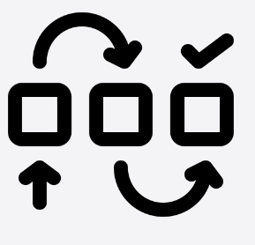 A mathematical process for calculations; a set of rules that, if followed, will give a desired result.

