Year 5 Science – Forces – Autumn 2
What should I already know? | What am I going to learn in this unit? | Vocabulary I need to know
- I can sort scientific evidence that has been used to support or refute ideas.  - I can record information using scientific diagrams and labels  - I can observe how magnets attracts or repel each other and attach some materials and not others  - Notice that some forces need contact between objects, but magnetic forces can act at a distance  - Compare how things move on different surfaces  - I can predict whether two magnets will attract or repel each other, depending on which poles are facing  - I can compare and group a variety of everyday materials on the basis of whether they are attracted to a magnet, and identify some magnetic materials  - I can explore the natural world around me  - I can find out how shapes of solid objects made from some materials can be changed by squashing, bending, twisting and stretching | - I can explain that unsupported objects fall towards the Earth because of the force of gravity acting between the Earth and the falling object  - I can identify the effects of air resistance, water resistance and friction, that act between moving surfaces  - I can recognise that some mechanisms including levers, pulleys and gears allow a smaller force to have a greater effect  - I can research how scientists (Galileo Galilei and Isaac Newton) helped to develop the theory of gravitation  - I can ask questions about the effects of air resistance  - I can observe the effects of friction and forces that make things begin to move, get faster or slow down  - I can gather and record data from my experiments | Forces  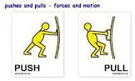 | Pushes or pulls
 |  | Gravity  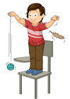 | A pulling force exerted by the Earth.
 |  | Earth’s Gravitational Pull  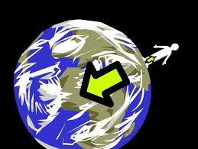 | The pull that Earth exerts on an object, pulling it towards Earth’s centre.
 |  | Upthrust  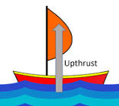 | A force that pushes objects up, usually in water.
 |  | Air Resistance  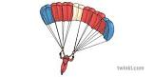 | A type of friction caused by air pushing against a moving object.
 |  | Water Resistance  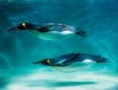 | A type of friction caused by water pushing against a moving object.

