Year 5 – History – Early Islamic Civilisation – A Golden Age
What should I already know? (Year 4) | What am I going to learn in this unit? | Vocabulary I need to know
- I know that the Vikings first came to Britain in 793 AD and settled in 850AD.  - I know that the original meaning of the word Viking was raider or looter.  - I can explain where the Vikings fit into Britain’s timeline.  - I know that the Vikings were from Scandinavia which is now known as Norway, Sweden and Denmark.  - I can give examples of what the Vikings traded around the world.  - I know that Vikings used longboats to travel long distances.  - I can explain why the Vikings came to Britain and why this was significant.  - I can give reasons why the Vikings wanted to stay in Britain.  - I can give examples of artefacts that have been found in Britain that tell us about how the Vikings lived.  - I can give examples of what was similar and what was different between the Viking and Saxon raids. | - I can accurately place civilisations in chronological order and state where they overlap.  - I can explain when and where the early Islamic civilisation developed.  - I can give reasons for why Baghdad became a major world power.  - I can explain what the House of Wisdom was.  - I can give examples of different areas of science and inventions that advanced during this time.  - I can name some important Islamic scholars.  - I can give examples of significant inventions during this time.  - I can explain what impact the inventions during this time had on our modern society.  - I can compare the similarities and differences between the Early Islamic Civilisation and Britain at the same time. | Civilisation 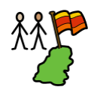 People living together in large groups with a social structure.  Islamic Islam is a religion that is still followed across the world today.  Advanced This means progressing quickly.  Algebra 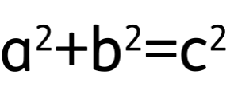 Part of maths where letters and symbols represent numbers.  Byzantine Empire Part of the Roman Empire from Italy and stretching east.  Chemistry The study of how different things mix together and what changes occur.  Ophthalmology The study of eyes and how we see.  Scholar Someone who studies and researches one thing to help make discoveries.  Surgery 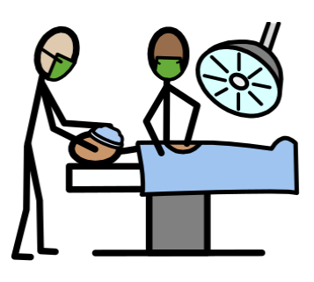 An operation to help fix something on the inside of the body.  Philosophy 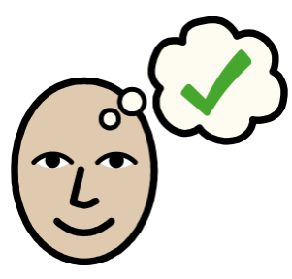 Asking questions about life and the world around them.

