Year 4 – Design and Technology – Textiles
What should I already know? | What am I going to learn in this unit? | Vocabulary I need to know
- I can use different techniques to cut and join paper and card.  - I can explain the properties of different 2D and 3D shapes.  - I can investigate and evaluate a range of different shell products.  - I can generate ideas to create a product that meets set criteria.  - I can analyse existing products for their effectiveness.  - I can create a design using annotated sketches on Microsoft Word to communicate my ideas.  - I can order the steps to make my product.  - I can use appropriate tools to measure, mark, cut, score and assemble my product.  - I can use Microsoft Word to create finishing products for my design.  - I can test and evaluate my product based on the design criteria. | - I know what is needed to make an electrical circuit.  - I know explain what a LED is.  - I know that a battery contains stored electricity and can be used to power products.  - I know that breaks in a circuit will stop it from working.  - I can create a working LED circuit using pressure as a switch.  - I can thread needles independently.  - I can use a running stitch and a backstitch accurately.  - I can produce a product plan for a purpose.  - I can persevere and adapt work when original ideas do not work.  - I know which materials are likely to give the best outcome.  - I can evaluate a product for both appearance and purpose. | Product 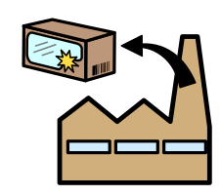 The final piece of what you are making. E.g. your decoration  LED Light Emitting Diode  Pressure Circuit 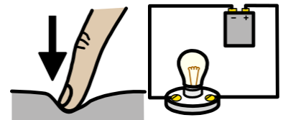 A box that contains an electrical circuit that becomes complete when you press down.  Threading 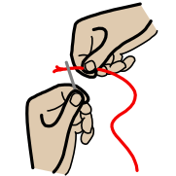 When you put the thread through the eye of the needle so you can sew with it.  Materials 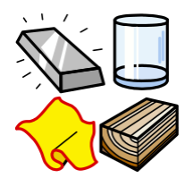 The different things you use to create the product e.g. felt  