Year 4 Science – States of Matter – Autumn 2
What should I already know? | What am I going to learn in this unit? | Vocabulary I need to know
- I can use classification keys to group, identify and name living things.  - I understand how changes to an environment could endanger living things.  - I know that living things can be grouped in a variety of ways | - I understand the different states of matter: solid, liquid and gas.  - I understand how some materials can change state  - I know the temperature at which some materials change state.  - I know the part played by evaporation and condensation in the water cycle.  - I understand the process of the water cycle  - I can observe and record what I see in during experiments in notes and tables.  - I can use a thermometer to measure temperature.  - I can report of my findings to link it to my knowledge about states of matter. | Water Cycle  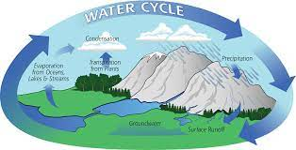 | The process that all water follows as it moves around Earth in different states.
 |  | Condensation  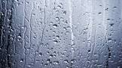 | The process of turning from a vapour/gas into a liquid.
 |  | Solid | A substance or object that if firm and stable in shape.
 |  | Liquid | A substance that flows freely but is a consistent volume.
 |  | Gas | A substance that expands freely and has no fixed shape & volume.
 |  | Evaporation  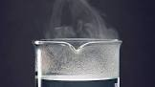 | The process of turning from liquid into vapour/gas.

