Year 4 Science – Electricity – Autumn 1
What should I already know? | What am I going to learn in this unit? | Vocabulary I need to know
- I know how to work some electrical items in my home.  - I know how to compare and group materials.  - I know some materials that make good insulators/conductors.  - I understand that energy can be used to power electrical items such as toasters, kettles, televisions.  - I understand that electricity can flow from one place to another.  - I know multiple items that are powered by electricity. | - I understand the function of a switch.  - I know the difference between a conductor and an insulator, giving examples of each.  - I can identify and name appliances that require electricity to function.  - I understand the names and components in a series circuit (including cells, wires, bulbs, switches, and buzzers)  - I can construct a simple series electrical circuit.  - I can observe patterns in electrical circuits.  - I can report my findings and link it to my knowledge of electricity.  - I can predict and test whether a lamp will light within a circuit.  - I can use research to find out which materials make effective conductors and insulators of electricity | Cell  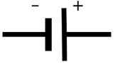 | An ‘electrical power supply’. Also called a battery
 |  | Conductor | A material or device that conducts or transmits electricity.
 |  | Insulator | A substance or device which does not readily conduct electricity.
 |  | Electricity  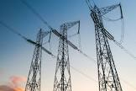 | A form of energy that can give things the ability to move and work.
 |  | Electrical Circuit  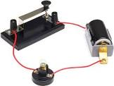 | A pathway that electricity can flow around.
 |  | Bulb  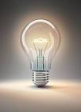 | A device that produces light from electricity. Lights up in a complete circuit.

