Year 3 – French – Les Instruments – Autumn 2
What should I already know? | What am I going to learn in this unit? | Vocabulary I need to know
- I know that French is spoken in France and other countries  - I can say hello, how are you and answer the question in French  - I am becoming more familiar with French pronunciation and phonemes  - I am starting to learn how to recall and remember words in a different language (French) | - I can recognise recall and spell up to ten instruments in French with the correct definite article/ determiner  - I can say ‘I play (an instrument)’ in French, using the first person of the verb ‘jouer’: ‘je joue’ (I play)  - I am developing my understanding of articles and determiners and how they work in French  - I can write simple sentences about up to ten instruments in French, using the first person of the verb ‘jouer’: ‘je joue’ (I play) | 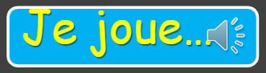  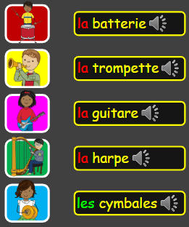  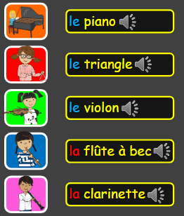  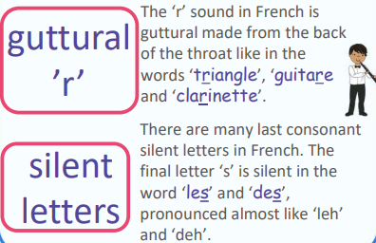  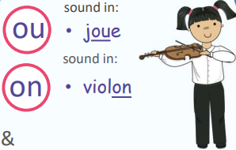  PHONICS

