Year 3 PE Autumn 2 – Dance and Multiskills
Dance |  |  |  |  | Multi skills
Sticky Knowledge |  |  |  |  | Sticky Knowledge
I can demonstrate accuracy when travelling in different ways. |  |  |  |  | I can maintain control of the ball.
I can effectively use the space to travel in different ways. |  |  |  |  | I can maintain control of a ball when travelling from once place to another.
I can show good control and balance when jumping. |  |  |  |  | I can manipulate what I do with the ball.
I can work with a partner when performing dance movements. |  |  |  |  | I can position my body to help me maintain possession whilst travelling.
We can combine our own dance movements to match the style of dance. |  |  |  |  | I can consider my speed and direction in order to evade an opponent.
I can improve my performance by taking on board feedback that has been given to me. |  |  |  |  | I can use my learnt skills to start to play matches.
Keywords: |  |  |  |  | Keywords:
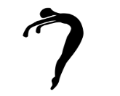  Control | 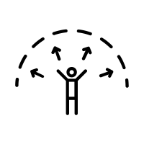  Space |  |  |  | 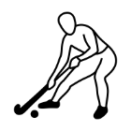  Control | 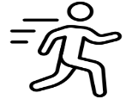  Travelling
Travel | Balance |  |  |  | Manipulate | Position
Emotions | Perform |  |  |  | Possession | Evade
Style | Feedback |  |  |  | Speed | Direction

