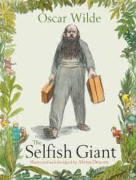

**Revisited Skills:**

* I can use noun phrases to describe a scene.
* I can use personification to describe.
* I can write in first person.
* I can use adjectives
* I can organise my ideas into paragraphs.

**New Skills:**

* I can use antonyms to create opposites
* I can make inferences about a character’s thoughts and feelings
* I can use a variety of sentence forms
* I can use adverbials to move between paragraphs

**Audience: Year 3**

**Form: Narrative**

**Purpose: To create a narrative to read to Year 3 about kindness**

**Tier 3 Vocabulary:**

**hail delicate linnet**

**casement bitterly gruff**

**Tier 2 Vocabulary:**

**heart imagine believe**

**difficult natural appear**

**breath separate special**

**Theme:** Kindness

**Related texts:**

The Polar Bear Explorers Club – Alex Bell

The Little Match Girl – Hans Christian Anderson