Year 6 – RE Autumn 2- Prophecy- Christianity
What should I already know? | What am I going to learn in this unit? | Vocabulary I need to know
Knowledge  - Know the concept of ‘Messages’ (year 3).  - Know the concept of ‘Interpretation’ (year 5).  Skills  - I can describe and explain the concept being studied, relate it to the wider faith and express its significance within key religious festivals.  - I can recognise that some features are different in the same religion and explain why this might be. | Inquire  - I can ask and respond to questions to identify the meaning of a key concept (Prophecy).  - I can identify that others may have a different understanding of the concept of prophecy and explain whether I agree and why.  Communicate  - I can show an insight and understanding into some of the way’s religion can influence a person’s life.  - I can describe an important event and compare difference people’s accounts and experiences of this same event.  Contextualise  - I can reflect on my own views and feelings with reasons on religious issues.  - I can explain how prophecy can influence a person’s life.  Evaluate  - I can give an accurate explanation as to the ways in which a religious person might value the concept of prophecy.  - I can explain why different people think that prophecy is important to the Christian faith.  Apply  - I can explain how the concept of prophecy features in my own life and express its importance to me.  - I can provide examples of how the concept of prophecy features in my own life and the lives of others. | Prophet 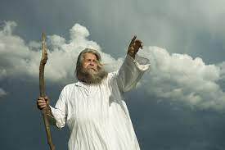 An inspired teacher or proclaimer of the will of God.  Prophecy A prediction of what will happen in the future.  Advent A season marking the preparation for and celebration of the birth of Jesus.  Messiah A ‘rescuer’ or ‘anointed’ one.  Magi Wise Men who followed the guiding star to Bethlehem.

