Year 4 – PSHE – Autumn two
What should I already know? | What am I going to learn in this unit? | Vocabulary I need to know
Relationships:  - I can identify qualities that make a positive friendship.  - I can explain what to do/who to talk to if a friendship is making me feel unsafe or unhappy.  - I can explain how positive qualities can build a strong, positive friendship.  Living in the wider world:  - I can explain what a community is.  - I can identify features of a community.  Health and wellbeing:  - I can explain what a balanced healthy lifestyle means.  - I can explain why it is important to have a balanced lifestyle for both our physical and mental health  - I can identify one way to treat myself if I became ill. | Relationships:  - I can explain how knowing someone online is different from knowing someone face to face.  - I can identify risks in communicating with someone I don’t know.  - I can identify ways to communicate respectfully.  - I can explain what to do if I am worried about any contact online.  - I can identify the difference between playful teasing, hurtful behaviour and bullying, including online.  - I can explain how to respond if I see or experience hurtful behaviour or bullying, including online.  Living in the wider world:  - I can explain what a community is.  - I can identify a community I belong to.  - I can identify how a community can be strong.  Health and wellbeing:  - I can explain how to brush and floss my teeth correctly.  - I can explain the importance of regular visits to the dentist.  - I can explain the effects of different foods and drinks on dental health. | 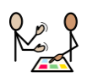  Communicate | Share or exchange information.
 |  | 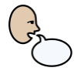  Report | To tell someone about something that has been seen or heard
 |  | 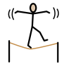  Risk | A situation which
 |  | 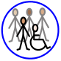  Community | A group of people who have the same things in common such as interests or where they live.
 |  | 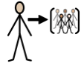  Belong | To be a member of.
 |  | 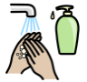  Hygiene | Routines/things we do to try and keep good health
 |  | 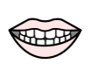  Dental | Teeth.

