Year 5 (RE) Knowledge Organiser – Autumn 2 Interpretation
What should I already know? | What am I going to learn in this unit? | Vocabulary I need to know
Knowledge  - Know the concept of ‘Messages’ (year 3).  - Know the meaning of the concept of ‘Symbol’ (year 4).  - Awareness of interpretation in other contexts.  - Know the concept of ‘Imagery’ (year 4).  Skills  - I can ask question to understand the meaning of a concept in my own life and the lives of those around me.  - I can describe and explain the concept and how these are important aspects of the faith. | Inquire  - I can ask questions and draw on previous knowledge of concepts to help me understand what the concept of interpretation means.  - I can give examples of the concept of interpretation and express why others might not share the same examples.  Contextualise  - I can explain how interpretation can impact on how a story/ event is recorded and why this is important.  - I can explain the concept of interpretation is seen in the Christian faith and identify difficulties with this.  Evaluate  - I can make comparisons between different interpretations and explain the significance of different viewpoints/ interpretations.  - I can recognise that some features are different in the same religion and explain why this might be.  Communicate  - I can explain some of the challenges I have faced with the idea of interpretation as well as some positives.  - I can explain the importance of the concept to myself and Christians.  Apply  - I can begin to explore the significance of the concept of interpretation and the implications if it didn’t exist.  - I can describe how the concept of interpretation impacts on my life and use examples to support my viewpoint. | Interpret To decide on the meaning of something based on the evidence you have.  Nativity 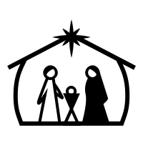 The story of the birth of Jesus Christ.  Recount 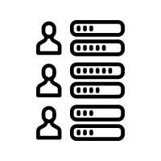 To retell the events of something that has happened.  Compare To find the similarities and differences between things.  Gospel The recordings of Christ’s life and teaching in the first four books of the New Testament (part of the bible.

