Year 4 – RE- Holy Mary Mother of God- Christianity
What should I already know? | What am I going to learn in this unit? | Vocabulary I need to know
Knowledge  - Know the main points of the Christian Christmas story (previous years).  - Know the meaning of the concept of ‘Precious’ (year 1) and ‘Sacred’ (year 3).  Know the meaning of the concept of ‘Imagery’ (year 3).  Skills  - I can give an example as to why a concept is important to a person of faith. I can say whether I agree or disagree.  - I can describe some of the ways in which people show that religion is important to them and recognise different viewpoints. | Inquire  - I can explain what the concept of holy means.  - I can ask questions to understand the meaning of the concept of holy.  Contextualise  - I can give examples of how Christian’s show that Mary is holy.  - I can understand the importance of the concept of Holy in the Christian religion and provide an example.  Evaluate  - I can recognise and describe accurately why Mary is considered holy to Christians.  - I can give an example as to why the concept of Holy is important to a person of faith. I can say whether I agree or disagree.  Communicate  - I can give an example of what I consider to be holy or similar in my life.  - I can give opinions as to what I think makes something holy and explain why.  Apply  - I can explain how the concept of holy/ special relates to my own life.  - I can explain how the concept of holy impacts on my own life and the lives of others. | Holy Something that is Godly and worthy of praise.  Mary 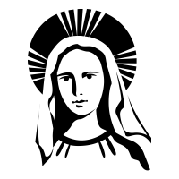 Was the mother of Jesus.  Impressions The wish to do or have something that you know you should not do or have.  Annunciation 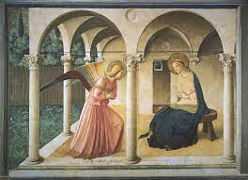 The announcement that Mary was pregnant with Gods son.  Incarnation 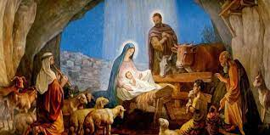 God became flesh/ human.

