` ``````````````````````````````````````````````````````````````````11``````````````````````````````````````````````````````````````````````````` ``` ` ` ` ` ` `` ` ````````````````````````16 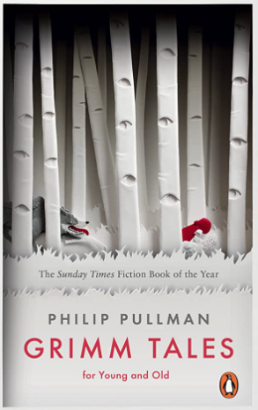

**Revisited Skills:**

* Using relative clauses to add additional detail to writing
* Writing consistently in the correct tense.
* Editing and improving my work.
* Accurately punctuating my writing to ensure it can be read cohesively.
* Orally create and retell a story with appropriate intonation and actions.
* To use expanded noun phrases to add detail.
* I can use a relative clause to add detail.

**New Skills:**

* I can recognise and use conventional language used in fairy tales.
* I am learning to use compound sentence in my writing to build and link ideas cohesively.
* I am learning to use complex sentences in my work to add detail.

**Audience:** Photo copies for library.

**Form:** Continue narrative

**Purpose:** to entertain and describe**.**

**Tier 3 Vocabulary:**

Enchanted betrothed damsel protagonist quest

**Tier 2 Vocabulary:**

Castle majesty conflict maiden resolution consequence enemy legend consequence immediately opportunity convenience community ancient sacrifice

**Theme:** consequences, choices, fantasy

**Related texts:**

**Clockwork – Philip Pullman**

**The Owls Service – Alan Garner**

**The Firework Maker’s Daughter – Philip Pullman**