Year 4- Geography – Food Distribution in the UK and Europe
What do I know already? | What am I going to learn? | Key Vocabulary
- I can name and explain 5 different types of weather we have in the UK.  - I can explain what the climate is like in the UK.  - I can describe the difference between weather and climate.  - I can explain how we use scientific equipment to record and gather data about weather.  - I can explain what a meteorologist does and how they predict weather patterns.  - I can create a weather forecast which has relevant and useful information in.  - I can give examples of different UK agricultural products.  - I can explain why some foods are important to the UK.  - I can research and present information about a UK crop.  - I can interpret different weather maps to understand previous, current and future weather patterns. | - I can explain the different climates in Europe and locate them on a map.  - I can interpret a simple climatic map.  - I can explain describe where the equator, Tropic of Cancer are in relation to European climates.  - I can explain the difference between grown, reared, and processed foods.  - I can explain what import, export, and trade means.  - I can give examples of food that are imported to the UK from Europe.  - I can explain why countries would choose to trade certain food rather than grow their own.  - I can give examples of human geographical features that might impact food distribution.  - I can give examples of physical geographical features that might impact food distribution.  - I can present my findings about European food distribution using Power point | Import  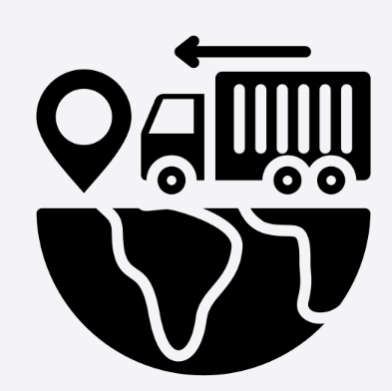  Export  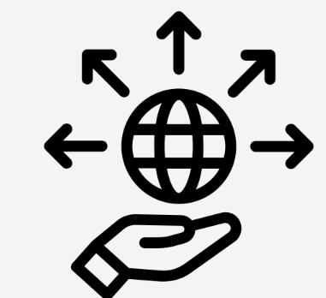  Trade  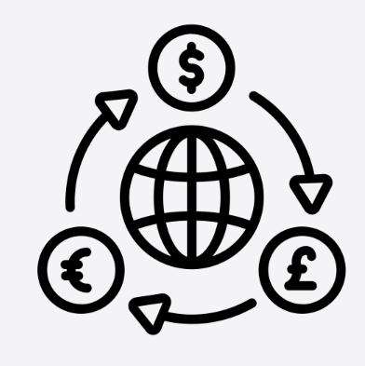  Harvest  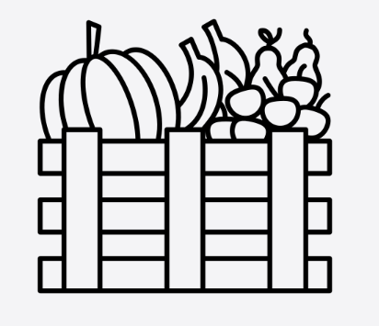  Climate  Physical Geographical Features  Human Geographical Features

