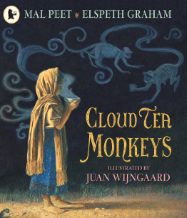h

**Revisited Skills:**

**I can use familiar punctuation accurately.**

**I can write a simple sentence.**

**I can use coordinating conjunctions to join two related clauses.**

**I can write a compound sentence.**

**New Skills:**

**Revision unit**

**I can write from memory simple sentences dictated by my teacher that includes words and punctuation I know.**

**I can extend my range of sentences with more than one clause.**

**Audience: Future self**

**Form: Diary entry**

**Purpose: To inform and recount**

**Theme**

**Friendship/Justice/Poverty**

**Related texts:**

**The Wolves in the Walls by Neil Gaiman**

**Journey to the Riversea by Eva Ibbotson**

**Sulwe by Lupita Nyong'o**

**Tier 2 Vocabulary:**

**Sleek, scarlet, indigo, burden, gossiped, dismayed, manage, hauled, plucking, outburst, canopy, scolded**

**Tier 3 Vocabulary:**

**Plantation, Overseer, buds, sprig, ox-cart, valley, Royal Tea-Taster, charcoal, copper kettle, porcelain Empress, turban**