Year 5 – Music– Autumn 2
What should I know already | What am I going to learn | Key Vocabulary
- I can use musical terminology to describe a piece of music.  - I understand how sharps and flats can affect tonality.  - I know how other cultures celebrate Harvest with music from their culture and can identify their sounds.  - I can play a variety of pitched and unpitched instruments.  - I can follow simple notation and play with accuracy.  - I can sing a song including songs in three parts with accuracy and attention to expressive detail.  - I can improvise using a non-western scale over a drone. | - I understand the context and history of a Medieval, Baroque and Romantic piece of music.  - I understand the difference between semibreves, minims, crotchets, rests, paired quavers and semiquavers.  - I understand how triads are formed.  - I can compose a melody within a given set of notes that evokes a specific mood.  - I can improvise using a non-western scale.  - I can compose a melody using a given scale (C major and A minor).  - I can perform simple chordal accompaniments.  - 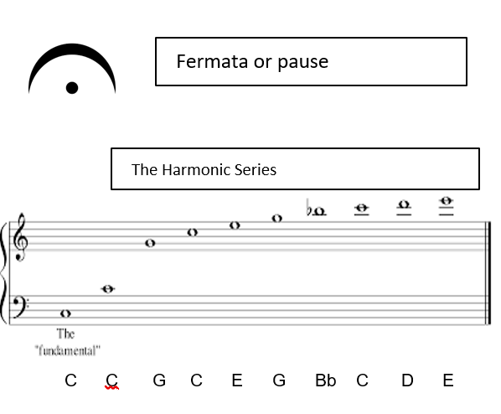 | Baroque An era of music from 1600 - 1750  Harmonic Series Notes that naturally occur without the use of valves on a brass instrument  Fermata A pause or hold on a note  Improvise Making music up as you go along / composing on the spot  Drone Two notes that are held under a melody particularly used in medieval music

