Year 3 – Music – Autumn 2
What do I know already | What am I going to learn | Vocabulary
- I know the difference between pulse and rhythm.  - I can recognise the pulse in a piece of music.  - I can recognise a rhythm and identify it accurately.  - I can compose a simple rhythm to a given word or phrase.  - I can clap and copy simple rhythms accurately.  - I can sing a song with accuracy and perform it in a group with other parts.  - I can perform from basic rhythm notation.  - I can create layered compositions using simple rhythmic patterns. | - I understand how stave notation works: rising and lowering in pitch like a ladder.  - I can place five notes accurately on the stave.  - I understand the context, intent and history around a piece of baroque music.  - I can sing a widening range of unison songs and rounds in varying styles and structures.  - I can play tuned and untuned instruments with increasing control and skill.  - I can compose and improvise using my voice, tuned and untuned percussion. | Treble Clef 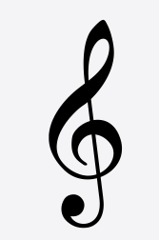 A symbol to guide us to know which note is which on a stave  Glockenspeil 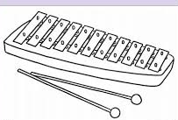 A percussion instrument made of metal that you hit with a beater  Pitch 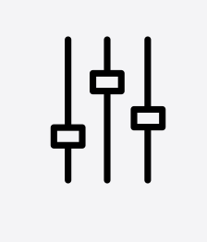 High or low notes  Pentatonic Scale 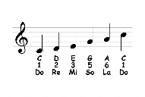 A scale of five notes  Improvise Make your own music up as you go along  Baroque 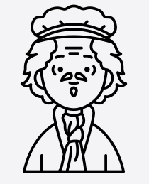 An era of time from 1600 – 1685 and what features the music had at that time

