Year 5 Computing Autumn 2
What should I already know? | What am I going to learn in this unit? | Vocabulary I need to know
- I can contribute to a class discussion to create e – safety rules  - I know how to use technology safely  - I know what acceptable and unacceptable behaviour means  - I know what acceptable and unacceptable behaviour is when using technology  - I know what inappropriate behaviour looks like in a range of contexts  - I know who to report concerns and inappropriate behaviour to a range of contexts  - I know how to report concerns and inappropriate behaviour in a range of contexts  - I know who my trusted adults are in school and outside of school  - I know what WWW is  - I know what the internet is  - I can explain the difference between www and the internet  - I know there are other services the internet can offer  - I know what a condition is  - I can identify a condition in an algorithm  - I can modify a condition in an algorithm | Digital Literacy:  - I know what makes a password strong  - I can create a strong password using a variety of numbers, letters and symbols  - I know what personal information is  - I know that some apps and websites may can read personal information  - I know that some apps and websites share personal information they read  - I know that some apps may request payments for additional content  - I know that I need to ask permission from an adult before purchasing content online or in an app  - I can explain why I need permission to make in app purchases  Computer Science:  - I know can explain what a condition is in programming  - I can identify ‘if…then…else’ is a condition used in programming | 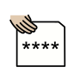 Password a series of letters or numbers — that's kept secret  Information acts provided or learned about something or someone  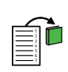 Content things that are inside something  Purchase to get by paying money for; buy  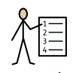 algorithm a sequence of instructions that are followed to complete a task  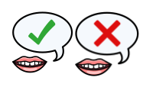 condition the state of something in the program that's true or false  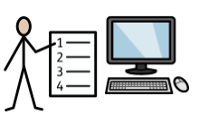 program a defined set of algorithms or processes that are completed in order to achieve a task  debug when you find an issue in the program that you have written and repair it

