Year 6 Science – Classifying Living Things – Autumn 1
What should I already know? | What am I going to learn in this unit? | Vocabulary I need to know
- I am able to give an example focussed on a supporting scientific theory, e.g. how much easier it is to life a heavy object using a pulley.  - I can carry out research when investigating a scientific theory.  - I can use scientific instruments when appropriate  - I understand what gravity is and its impact on our lives.  - I know about the effect of air and water resistance.  - I know how levers, pulleys and gears allow a smaller force to have a greater effect | - I understand how living things are classified by similar characteristics.  - I can explain why living things are classified.  - I explain different characteristics of plants for classification.  - I can identify different microorganisms and what they do.  - I can create closed questions to use in a classification key.  - I can record information about living things in a classification key.  - I can identify animals that don’t fit the typical classification characteristics/groups.  - I can report my findings about the classification of different living things. | Classify | To sort into different groups
 |  | Characteristics  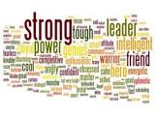 | Special qualities or appearances that make an individual or groups of things different to others.
 |  | Taxonomist  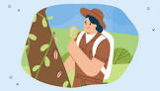 | A scientist who classifies different living things into categories.
 |  | Key  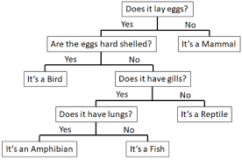 | A series of questions about the characteristics of living things.
 |  | Species  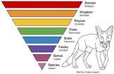 | A group of animals that can reproduce to produce fertile offspring.
 |  | 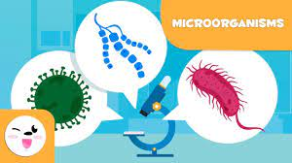  Microorganisms | An organism that can only be seen using a microscope.

