Year 6 PE Autumn 1 – Football and Gymnastics
Gymnastics |  |  |  |  | Tag Rugby
Sticky Knowledge |  |  |  |  | Sticky Knowledge
I can use a range of pathways, levels and speeds when travelling. |  |  |  |  | I can consider my teams positioning and communicate before and during match play to stop an opponent scoring.
I can combine different methods of travel in a routine. |  |  |  |  | I can make a quick decision on when to apply pressure to an opponent to ensure that I am successful.
I can show symmetry and asymmetry in different rolls. |  |  |  |  | I can combine a variety of skills in order to score a try.
I can begin to balance on my hands. |  |  |  |  | I can experiment with different formations and decide which is the most effective for our team.
I can show acrobatic balances with a partner on the floor. |  |  |  |  | I can experiment with different formations and decide which is the most effective in different match scenarios.
With a partner, I can perform acrobatic balances with fluency and control in a routine.
Keywords: |  |  |  |  | Keywords:
Travel | Create |  |  |  | Evade | Formations 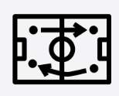
Match 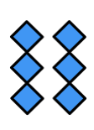 | Position |  |  |  | Create | Explore
Execution | Tension 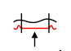 |  |  |  | Try 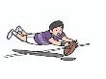 | Scenario
 |  |  |  |  | Opponent

