Year 6 Computing Autumn 1
What should I already know? | What am I going to learn in this unit? | Vocabulary I need to know
- I know what acceptable and unacceptable behaviour means  - I know what acceptable and unacceptable behaviour is when using technology  - I know what inappropriate behaviour looks like in a range of contexts  - I know who to report concerns and inappropriate behaviour to a range of contexts  - I know how to report concerns and inappropriate behaviour in a range of contexts  - I know who my trusted adults are in school and outside of school  - I know what excel is  - I know that excel is used to present data  - I know what formulae means  - I can use pre – loaded formulae to solve calculations  - I can edit cells in a spreadsheet  - I can format difference in a cell  - I know what is meant by programming  - I know how selection works in programming  - I can design a programme which includes selection | Digital Literacy:  - I can participate in a class discussion  - I can contribute to a class discussion to create e – safety rules  - I know how to use technology safely  - I know what acceptable and unacceptable behaviour means  - I know what acceptable and unacceptable behaviour is when using technology  - I know what inappropriate behaviour looks like in a variety of contexts  - I know who to report concerns and inappropriate behaviour to a variety of contexts  - I know how to report concerns and inappropriate behaviour in a variety of contexts  - I know who my trusted adults are in school and outside of school  Information Technology:  - I know what a network is  - I know and can explain how a network works  - I know how the internet works  - I know how data travels across networks  - I know how data travels in packets  - I know data packets can be broken and reconstructed | Participate having or taking part in an undertaking, activity, or discussion  Sensible having or showing good sense; wise  Inappropriate not right or proper for the time or place  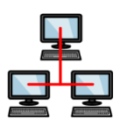 Network when a number of computers are connected or linked together  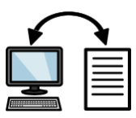 Data units of information  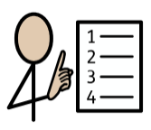 Protocol A set of rules defined for communication among the devices using a network

