Year 5 – Geography – Rivers
What should I already know? | What am I going to learn in this unit? | Vocabulary I need to know
- I can explain the structure of the earth and what a tectonic plate is.  - I can explain the 3 different ways that plates move and how slow the process is.  - I can explain the 5 features of an earthquake.  - I know where some of the deadliest earthquakes have taken place.  - I can explain that volcanoes can be active, dormant or extinct.  - I can explain the 5 deadly features of a volcanic eruption.  - I can explain why some people want to live near active and dormant volcanoes. | - I can explain the different features of a river.  - I can explain how the different features are grouped by the course of the river.  - I can recognise the key events that contribute to river flooding.  - I can identify the impacts that flooding has upon local people living and working in an area.  - I can understand how to read an OS map identifying the key, scale and contour lines.  - I can identify up to 6 digit grid references for locations on a map.  - I can use my knowledge of rivers to identify the location of pictures where they fit within a river course.  - I can explain how waterfalls are formed.  - I can create a model of a waterfall and label each part of the waterfall.  - I can use scientific equipment to record measurements of rivers including velocity, depth and width. | River 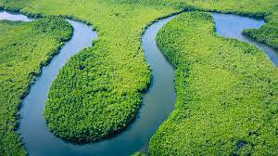 A river is a ribbon-like body of water that flows downhill from the force of gravity. A river can be wide and deep, or shallow enough for a person to wade across.  Mouth 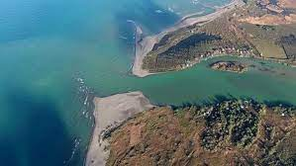 Where a river meets another large amount of water- it could be the sea or a bigger river.  Meander 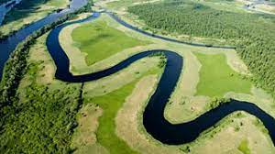 A meander is when water flows in a curvy, bendy path, like a snake. As a river makes its way through an area that is relatively flat, it often develops bends as it erodes.  Erosion 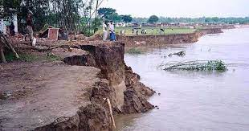 Erosion involves the wearing away of rock and soil found along the riverbed and banks.  Riverbed 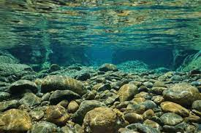 The ‘floor’ or ‘ground’ at the bottom of the river. Water flows over it.  Other bodies of water:  Lake  Stream  Estuary  Pond

