Year 5 Science – Properties of Materials – Autumn 1
What should I already know? | What am I going to learn in this unit? | Vocabulary I need to know
- I can report of my findings to link it to my knowledge about states of matter.  - I can observe and record what I see in during experiments in notes and tables.  - I can use a thermometer to measure temperature.  - I understand the different states of matter: solid, liquid and gas.  - I understand how some materials can change state  - I know the temperature at which some materials change state.  - I know the part played by evaporation and condensation in the water cycle.  I understand the process of the water cycle | - I understand how to compare and group different materials by their properties.  - I understand the process of dissolving.  - I know how to use my knowledge of the states of matter to help me separate mixtures.  - I know everyday uses for particular materials due to their properties.  - I understand how to demonstrate reversible changes and explain irreversible changes  - I can plan enquiries to investigate the properties of materials and mixtures.  - I can record data in tables and bar charts.  - I can report my findings orally and written. | Properties  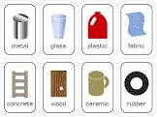 | A quality belonging to something, e.g. hardness, conductivity, flexibility, magnetism, transparency.
 |  | Conductor  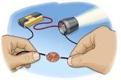 | A material that heat or electricity can easily travel through.
 |  | Insulator  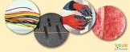 | A material that does not let heat or electricity travel through them.
 |  | Dissolving  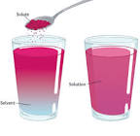 | Creating a solution made when solid particles are mixed with liquid particles.
 |  | Soluble | Materials that dissolve.
 |  | Insoluble | Materials that don’t dissolve.

