Year 5 Music: Sounds of Autumn: Autumn One
What should I already know? | What I am learning | Key Vocabulary
- I am beginning to make compositional decisions about the structure of improvisations  - I understand the difference between major and minor tonalities  - I know the difference between minims, crotchets, paired quavers and rests  - I can sing a broad range of unison songs with the range of an octave  - I can improvise on a limited range of pitches  - I can play and perform melodies following staff notation using a small range  - I can perform in two or more parts (e.g. melody and accompaniment). | - I can use musical terminology to describe a piece of music.  - I understand how sharps and flats can affect tonality.  - I know how other cultures celebrate Harvest with music from their culture and can identify their sounds.  - I can play a variety of pitched and unpitched instruments.  - I can follow simple notation and play with accuracy.  - I can sing a song including songs in three parts with accuracy and attention to expressive detail.  - I can improvise using a non-western scale over a drone. | Concerto | A form of music with a soloist and an orchestra
 |  | Polyrhythm | Many rhythms put together at the same time
 |  | Chaal | The rhythm used in Bhangra music
 |  | Bhangra | A style of music from the Punjab that celebrates the harvest and how it has been adapted with Western Culture
 |  | Rag Bhairav | A scale used in Indian Classical music to signify the morning and light
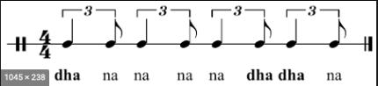
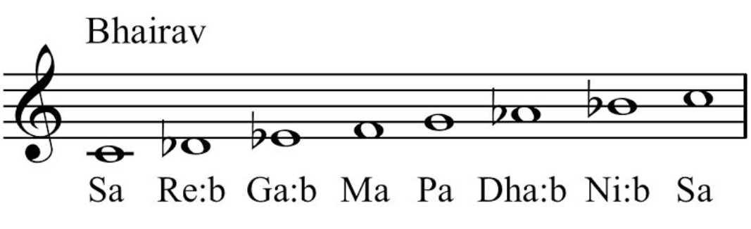
C D flat E flat F G A flat B flat C

