Year 5 PE Autumn 1 – Football and Gymnastics
Gymnastics |  |  |  |  | Football
Sticky Knowledge |  |  |  |  | Sticky Knowledge
I can travel sideways. |  |  |  |  | I can use dribbling skills to evade an opponent.
I can make symmetrical and asymmetrical shapes in the air. |  |  |  |  | I can shoot with a variety of techniques whilst maintaining accuracy.
I can show different finishing positions when rolling. |  |  |  |  | I can make a decision on which body part to use when the ball is in flight.
I cam mirror and match my partner’s symmetrical and asymmetrical shapes. |  |  |  |  | I am learning to use passing and moving skills to create a shooting opportunity.
I can perform balances with control, showing good body tension. |  |  |  |  | As a team player, I can use a variety of attacking skills to score a goal against an opponent.
I can create and perform a sequence with my partner. |  |  |  |  | As a team player, I can use a variety of attacking skills during match play.
Keywords: |  |  |  |  | Keywords:
Sideways 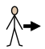 | Symmetry |  |  |  | Evade | Shoot 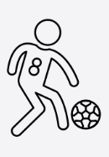
Finishing 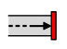 | Position |  |  |  | Flight 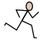 | Movement 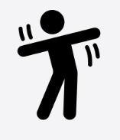
Mirror/Match | Tension 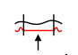
Execution

