Year 4 – French – Je me présente
What should I already know? | What am I going to learn in this unit? | Vocabulary I need to know
- I can say ‘Hello’ in French  - I can ask and answer the question ‘How are you?’ in French  - I can ask and answer the question ‘What is your name?’ in French  - I can listen to someone speaking French and understand them  - I can answer simple questions in French  - I can count to ten in French  - I am becoming more familiar with French pronunciation and phonemes  - I am starting to learn how to recall and remember words in a different language (French) | - I can ask and answer the question, ‘How old are you?’ in French  - I can ask and answer the question, ‘Where do you live?’ in French  - I can ask someone’s nationality in French  - I can say the numbers eleven to twenty in French  - I know that there are masculine and feminine forms for nationality in French  - I can read and understand simple sentences describing name, age and nationailty in French  - I can write simple sentences describing name, age and nationality in French | 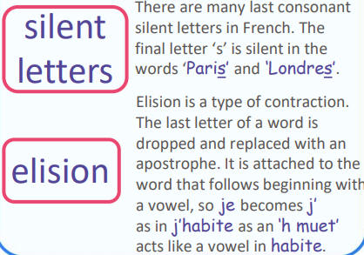  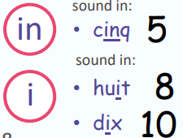  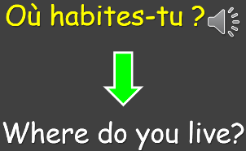  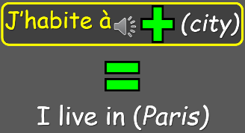  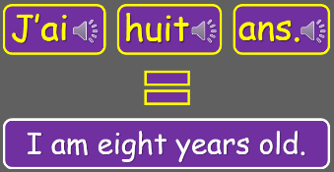  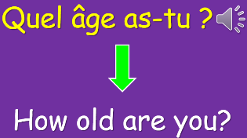  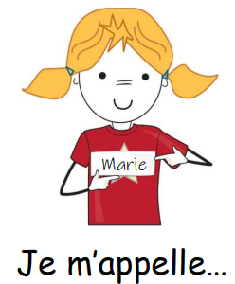  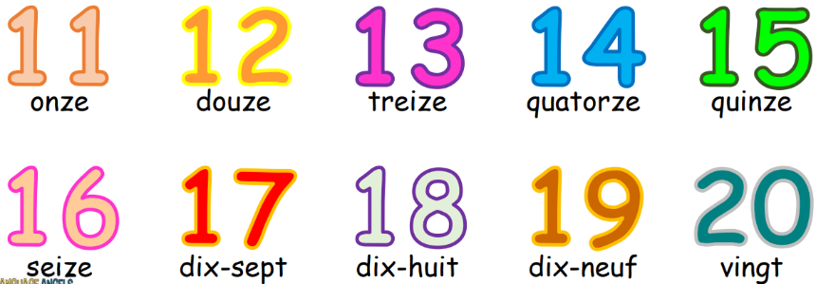  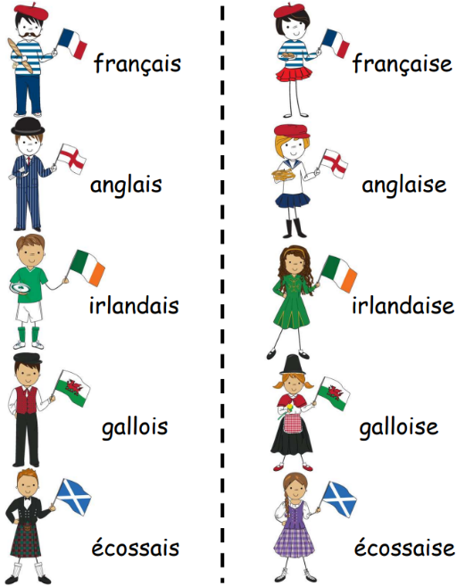  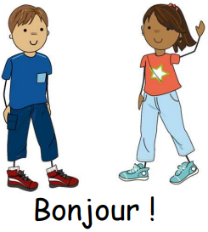  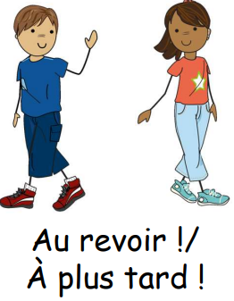  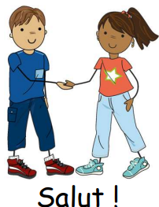  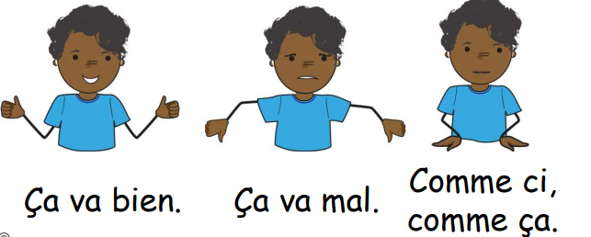  PH ONICS

