Year 4 PE Autumn 1 – Football and Gymnastics
Gymnastics |  |  |  |  | Football
Sticky Knowledge |  |  |  |  | Sticky Knowledge
I can travel using different pathways on the floor. |  |  |  |  | I can create space to receive a pass.
I can confidently leap forward in a routine. |  |  |  |  | I can use different parts of my foot to receive a ball.
I can add a quarter or half turn into a jump before landing. |  |  |  |  | I can pass a ball with accuracy using both feet.
I can use my core strength to hold a balance. |  |  |  |  | I can pass from a variety of distances.
With a partner, I can use rolls, balances and jumps to create a sequence. |  |  |  |  | I can use different parts of my body to receive a ball.
I can perform a short sequence using what we have learned. |  |  |  |  | I can control a ball away from an opponent to create space.
Keywords: |  |  |  |  | Keywords:
Roll 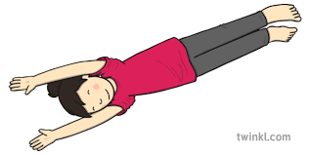 | Half turn 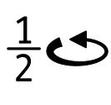 |  |  |  | Create space | Receive 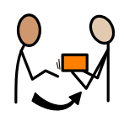
Pathways 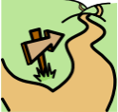 | Core strength |  |  |  | Accuracy | Passing 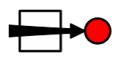
Leap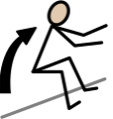 | Forward Roll 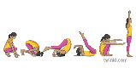 |  |  |  | Body 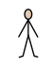
Quarter turn