Year 3 – Design and Technology – Mechanisms and Levers
What should I already know? | What am I going to learn in this unit? | Vocabulary I need to know
(From Year 2)  - I can design purposeful, functional, appealing products based on design criteria.  - I can generate ideas in different ways.  - I can use a range of tools and equipment to cut, join and shape.  - I can select the materials I need for a purpose.  - I can evaluate a range of existing products.  - I can evaluate my own ideas against the design brief.  - I can begin to use levers, sliders and wheels in my designs. | - I can identify different mechanisms such as flaps, sliders and levers in different contexts.  - I can analyse a variety of products which have levers and linking mechanisms.  - I can use experimenting to help me develop my ideas and create a final design.  - I can explain what a prototype is and why they are useful.  - I can explain my choices of materials.  - I can communicate what my idea is and explain how it will work to another person.  - I can order the steps I need to make my final product.  - I can select and use appropriate tools with accuracy including cutting, shaping and joining.  - I can demonstrate how to use finishing techniques to make my final product look exciting.  - I can evaluate my product for its appearance, durability and whether it is easy to use. | Mechanism A device used to create movement.  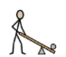 Lever A rigid bar which moves around a pivot. Levers are used in lots of every day products.  Guide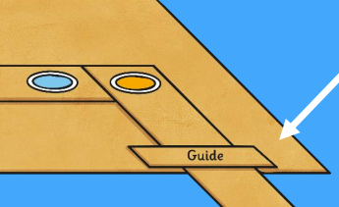 A short card strip to keep a lever in place  Pivot 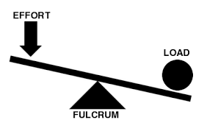 Something like a split pin that is used to join two pieces of card together but they can still move.  Input and Output 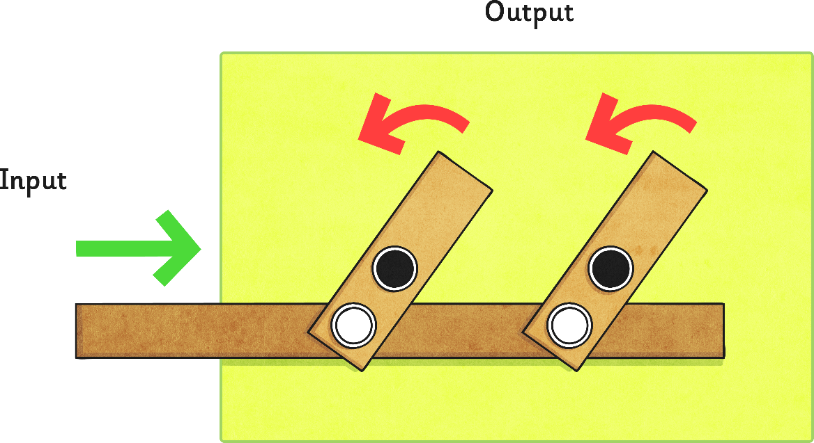 Input is the movement put onto the lever to make the other part move. The other moving parts are the output.  Motion (movement) 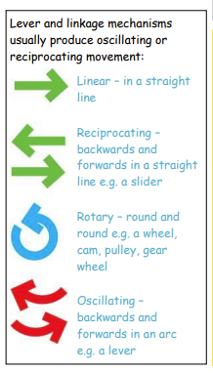  Prototype A model of the final product to see if the design and measurements work.

