Year 3 Science – Forces & Magnets – Autumn 1
What should I already know? | What am I going to learn in this unit? | Vocabulary I need to know
- I understand that sometimes objects pull themselves together by an invisible force (magnetic)  - I understand that metal and rocks can be magnetic.  - I know that my fridge might have magnets on  - I know how to make things stop and start.  - I understand that sometimes objects pull themselves together by an invisible force (magnetic)  - I understand that metal and rocks can be magnetic.  - I know that my fridge might have magnets on  - I know how to make things stop and start. | - I know about and describe how objects move on different surfaces  - I understand how a simple pulley works and use to lift an object.  - I know how some forces require contact and some do not, giving examples.  - I can explain how magnets attract and repel.  - I know that magnets have two poles.  - I can compare how things move on difference surfaces.  - I can make observations of magnets attracting and repelling each other.  - I can compare and group a variety of everyday materials based on whether they are attracted to a magnet.  - I can predict whether two magnets will attract or repel each other, depending on which way the poles are facing | Force  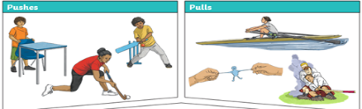 | A push or a pull and is measured in Newtons
 |  | Magnetic | An object or material that moves
 |  | Pole  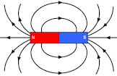 | The strongest part of a magnetic. Split into the north and south pole. They are opposites
 |  | Attract | This is the word we use to explain when two magnets connect.
 |  | Repel | This is the world we use to explain when two magnets will not connect.
 |  | 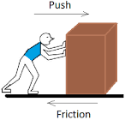  Friction | A force that slows objects down

