Year 3 PE Autumn 1 – Gymnastics and Multi-Skills
Gymnastics |  |  |  |  | Multi-skills
Sticky Knowledge |  |  |  |  | Sticky Knowledge
I can travel in different ways changing speed and direction. |  |  |  |  | I can travel at different speeds.
I can travel with an object. |  |  |  |  | I can travel with a partner.
I can aim and send a ball. |  |  |  |  | I can complete a stag jump.
I can use my hands and feet to receive a ball. |  |  |  |  | I can create symmetrical and asymmetrical shapes with my body.
I can use underarm and overarm to send an object. |  |  |  |  | I can complete a forwards roll.
I can combine a variety of skill and use them in a game. |  |  |  |  | I can create a short sequence of 6 elements using what I have learned.
Keywords: |  |  |  |  | Keywords:
Travel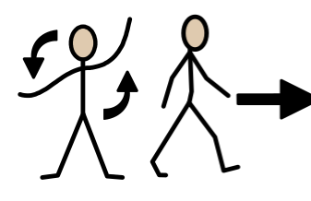 | Aim 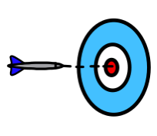 |  |  |  | Speed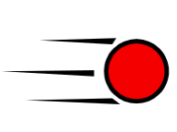 | Jump 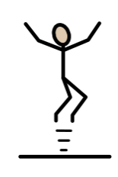
Send 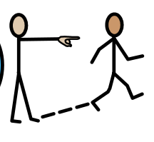 | Receive 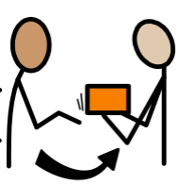 |  |  |  | Partner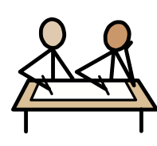 | Asymmetrical 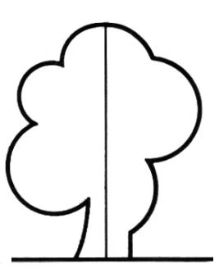
Underarm 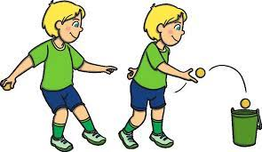 | Overarm 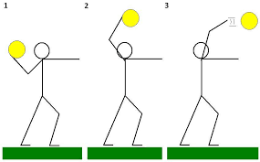 |  |  |  | Symmetrical 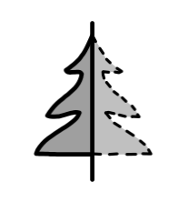 | Shape 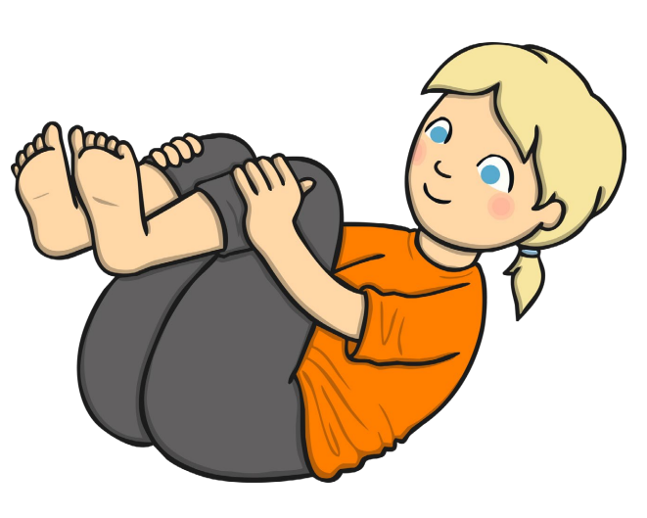
Combine 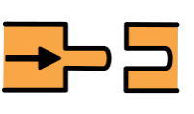 |  |  |  |  | Roll 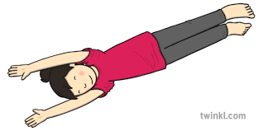 | Sequence 