Year 3 Computing Autumn 1
What should I already know? | What am I going to learn in this unit? | Vocabulary I need to know
 | Digital Literacy:  - I can contribute to a class discussion to create e – safety rules.  - I know how to use technology safely.  - I know what inappropriate behaviour looks like in school.  - I know who to report concerns and inappropriate behaviour to in school.  - I know how to report concerns and inappropriate behaviour in school.  - I know who my trusted adults are in school and outside of school.  Computer Science:  - I know what a sequence is.  - I know how to write instructions for a task.  - I can plan, write, evaluate, and edit a sequence of instructions for an everyday task.  - I know what an input is.  - I know what an output is.  - I can categorise inputs and outputs.  - I know that a technology uses inputs and outputs. | 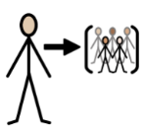 Participate to take part  Concern a feeling that you want them to be happy, safe, and well  Inappropriate not useful or suitable for a particular situation or purpose  Online connected to a computer or telecommunications system (as the Internet)  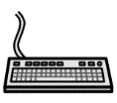 Input any electronic device that sends data to a computer  Output what comes out of something  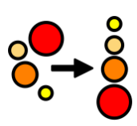 Sequence a series of events that must be performed in order to achieve a task  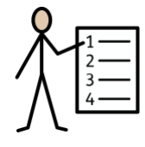 Algorithm a sequence of instructions

