Year 3 – Geography – Where we live
What should I already know? | What am I going to learn in this unit? | Vocabulary I need to know
(From KS1)  - I can name the 4 countries that make up the UK.  - I can explain some differences between a city, town and village.  - I know the hottest and coldest seasons in the United Kingdom.  - I can name the 7 continents and 5 oceans on our planet.  - I can use aerial photographs and plan perspectives to recognise landmarks and basic human and physical features.  - I can create a simple map; and use symbols in a key.  - I can explain the difference between human and physical geography. | - I can name and map the geographical regions of the UK and where I live.  - I can name and locate the cities near where I live and explain what a city is.  - I can name and locate the counties near where I live and explain what a county is.  - I can use and interpret maps and atlases of the United Kingdom to identify local cities and counties.  - I know that I live in the city of Southampton.  - I can explain what we mean by settlement and how land use influences settlements.  - I know the 4 settlement types – city, town, hamlet and village.  - I know that Southampton is made up of different suburbs and our school is in Bitterne.  - I can name similarities and differences between the New Forest and Bitterne.  - I can gather, record and classify information in a variety of ways to help answer questions.  - I can present findings selecting tables, charts and graphs and make observations | Settlements 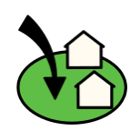 A settlement is a place where people live.  Urban 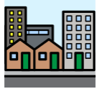 An area where a large number of people live near to each other. Urban areas have lots of buildings and roads.  Rural 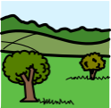 An area located outside of towns and cities, sometimes called the countryside.  Suburban 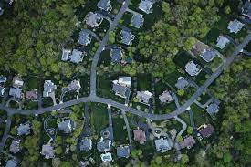 An area on the edges of towns and cities where people live.  Population 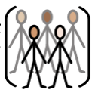 The number of people living in an area.  Observations 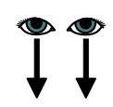 What you see during your fieldwork- what is the same and what is different about two areas.

