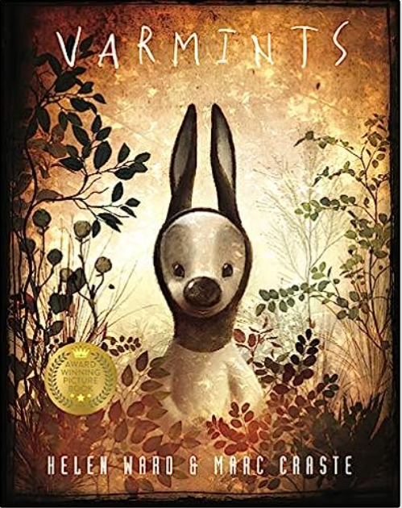

**Tier 3 Vocabulary:**

pollination vermin

germination dispersal

fertilisation

**Tier 2 Vocabulary:**

explanation appear often

process complete height

purpose natural cycle

knowledge

**Theme:** Finding Freedom

**Related texts:**

The Polar Bear Explorers Club – Alex Bell

Down, Down, Down: A Journey to the Bottom of the Sea – Steve Jenkins

The Plastic Problem – Audrey

**New Skills:**

* I can use figurative language devices
* I can use commas after fronted adverbials
* I can use subheadings to ensure a reader can understand my explanation text.

**Revisited Skills:**

* I can use noun phrases to describe a scene.
* I can use contrasting conjunctions to describe two scenes.
* I can use adverbs and prepositions of time to order
* I can group similar information into paragraphs

**Audience: Varmints hoping to grow new life.**

**Form: Information leaflet.**

**Purpose: To inform and describe.**