Year 5 – Design and Technology – Textiles
What should I already know? | What am I going to learn in this unit? | Vocabulary I need to know
(Year 4 Textiles)  - I know what is needed to make an electrical circuit.  - I know explain what a LED is.  - I know that a battery contains stored electricity and can be used to power products.  - I know that breaks in a circuit will stop it from working.  - I can create a working LED circuit using pressure as a switch.  - I can thread needles independently.  - I can use a running stitch and a backstitch accurately.  - I can produce a product plan for a purpose.  - I can persevere and adapt work when original ideas do not work.  - I know which materials are likely to give the best outcome.  - I can evaluate a product for both appearance and purpose. | - I can explain what a design brief is and create a plan that meets it.  - I can give different examples of fastenings and explain which ones are the best for certain products.  - I can create pattern pieces that can be used to create multiple identical products.  - I can measure, mark and cut fabric accurately and in a way that minimises wastage.  - I can use a range of stitches (running, backstitch and blanket) and select the right stitch for a purpose.  - I can stitch pieces of material together ensuring there are no holes and that the stitches are strong enough to hold a product inside.  - I can use applique to attach pieces of fabric for decoration.  - I can add a fastening that works.  - I can assess and evaluate my product for its functionality and marketability. | Product 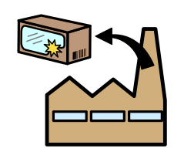 The final piece of what you are making. E.g. your bag  Fastening A popper, zip or button that is used to join two pieces of material together that can then be undone.  Functionality 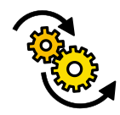 Whether a product does what it is supposed to do and whether it works.  Threading 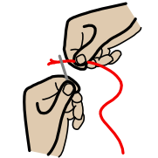 When you put the thread through the eye of the needle so you can sew with it.  Applique 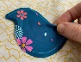 Needlework in which pieces or patches of fabric in different shapes and patterns are sewn or stuck onto a larger piece to form a picture or pattern.  Marketability 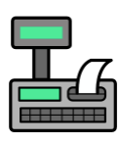 Whether something is likely to sell and whether people will want to buy it.  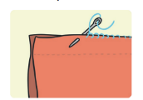 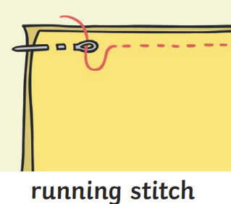 Blanket stitch 