Year 4 – History – Saxons
What should I already know? | What am I going to learn in this unit? | Vocabulary I need to know
- I know the key details of the three separate Roman invasions of Britannia (BC 55, BC 54 – Julius Caesar and AD 43 Claudius) including dates and leaders.  - I can explain the difference between a battle and an invasion.  - I know the duration of Roman control of Britain after the invasion of AD 43.  - I can explain the changes made to and the impact upon Britain by the Romans after the invasion of AD 43.  - I can explain key points of rebellions in Britain against the Roman invasion e.g. Boudicca and Picts. | - I can explain when the Romans left Britain and give an example of other Empires across the world.  - I can sequence key events in chronological order.  - I know where different Saxons (Angles, Saxons, Jutes) came from and why they came to England.  - I can list some push/pull reasons for the Saxon invaders and settlements.  - I can explain the influence that Saxon life had on modern Britain.  - I can name the Saxon kingdoms.  - I can give examples of what life was like in Saxon Britain.  - I can interpret different sources and say what it teaches us about Saxon Britain.  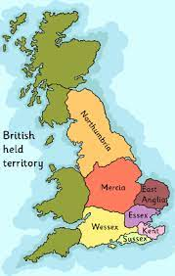 | Saxons, Angles and Jutes The names of 3 of the biggest tribes to invade Britain after the Romans left.  Invaders People who go to different places and attack.  Migration When people move from one place to another to live e.g. from France to Britain  Influence How something changes another thing or changes how someone thinks.  Settlements Where people create new places to live like villages.  Chronology In time order  Legacy Values, rules and influences that are left from someone or a group of people.  The 7 Saxon Kingdoms 1)Northumbria 2) Mercia 3) Wessex 4) Sussex 5) Kent 6) Essex 7)East Anglia

