Year 3 – RE- Messages- Christianity
What should I already know? | What am I going to learn in this unit? | Vocabulary I need to know
Knowledge  - Know the stories Jesus was spreading/ giving (concept of Change- year 2)  - Know the meaning of the word stories.  - Personal experience of receiving/ giving messages.  Skills  - I can ask simple questions about the meaning of a concept.  - I can give an example of how the concept is seen in my life.  - I can retell a story related to a particular faith. | Inquire  - I can describe clearly, in simple terms, the meaning of the concept of messages.  - I can begin to express ideas about the benefits of messages within stories.  Contextualise  - I can retell the key parts of Christian stories.  - I can begin to identify why the messages contained within a story are important to believers.  Evaluate  - I can say whether I agree or disagree with all or some parts of the Christian message within a story.  - I can express my view on the importance/ value of messages within stories.  Communicate  - I can identify a message that I think is important to the world around me.  - I can express whether an understanding of the concept of messages is important to me and why I think it might be important to others.  Apply  - I can describe simple examples of how responses to the concept of messages relates to my own life and the lives of others.  - I can identify some differences the concept makes to the lives of religious people and myself. | Message A written, verbal or recorded communication.  Parable 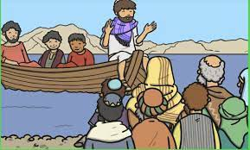 A simple story used to tell a message to an audience.  Prodigal Spending money or using resources recklessly.  Jesus The founder of Christianity.  Christianity The religion followed by Christians.

