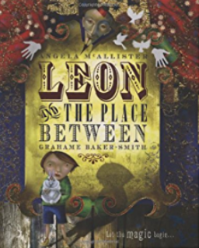

**Revisited Skills:**

From KS1

Capital letters and full stops

Different sentence forms

**New Skills:**

Expanded noun phrases

Identifying and using a range of word classes

Multiclause sentences using ‘if’

Figurative language to describe a scene

Punctuate speech

**Audience: Year 3**

**Form: To entertain**

**Purpose: Third person fantasy narrative**

**Tier 3 Vocabulary:**

Lanterns, braid, skittles, jugglers, tambourines, barrel organ, carousel, mechanical toys, ballerina, acrobat, pantaloon, magician, enchanted