Year 5 – PSHE – Autumn one
What should I already know? | What am I going to learn in this unit? | Vocabulary I need to know
Relationships:  - I can explain the term diversity.  - I can explain why we should discuss difference respectfully.  Living in the wider world:  - I can identify cash, card and e-payments as way of payment.  - I can identify a positive a negative effect of money.  - I can explain how to seek support with money.  Health and wellbeing:  - I can explain why personal hygiene routines are important.  - I can identify ways that I look after my personal hygiene.  - I can explain how to get information, help and advice about puberty.  - I can recognise the emotional changes I may experience with puberty.  - I can identify a trusted adult I would discuss the challenges of puberty with. | Relationships:  - I can explain how a healthy friendship may make people feel included.  - I can identify strategies to help someone feel included.  - I can explain how to seeks support if I feel excluded or lonely.  - I can explain what consent means and why we should respect someone’s choice.  - I can explain that consent can be given and taken away.  - I can identify how consent keeps me safe and why it is important.  Living in the wider world:  - I can explain ways we can protect the environment.  - I can explain why it is important to protect the environment.  Health and wellbeing:  - I can explain how sleep contributes to a healthy lifestyle.  - I can identify healthy sleep strategies and how I would maintain them.  - I can explain why a healthy sleep lifestyle would be good for my mental and physical health. | 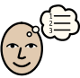  Strategy | A plan, method or idea on how to achieve something.
 |  | Respect | A feeling of caring for others’ wellbeing and showing this through our own behaviours and actions towards others.
 |  | 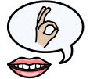  Consent | Giving someone a choice about touch or actions and respecting their answer.
 |  | 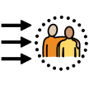  Protect | To defend or keep safe.
 |  | Environment | Our surroundings or conditions that we are in.
 |  | 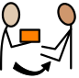  Contribute | To give to someone or something.
 |  | 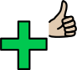  Healthy | Showing good mental and physical wellbeing.

