Year 4 – PSHE – Autumn one
What should I already know? | What am I going to learn in this unit? | Vocabulary I need to know
Relationships:  - I can explain how to treat others and how to be treated politely.  - I can identify ways people show respect and courtesy in different cultures and in wider society.  Living in the wider world:  - I can explain what a personal goal is.  - I can identify my own personal goal.  - I can explain why setting a personal goal is good for my mental health.  Health and wellbeing:  - I can recognise how feelings can be expressed (words, actions and body language).  - I can recognise that feelings can change overtime and become more or less powerful.  - I explain how to manage risk in everyday situations.  - I can identify an exit strategy I could use in a risky situation that I do not feel comfortable with. | Relationships:  - I can identify qualities that make a positive friendship.  - I can explain what to do/who to talk to if a friendship is making me feel unsafe or unhappy.  - I can explain how positive qualities can build a strong, positive friendship.  Living in the wider world:  - I can explain what a community is.  - I can identify features of a community.  Health and wellbeing:  - I can explain what a balanced healthy lifestyle means.  - I can explain why it is important to have a balanced lifestyle for both our physical and mental health  - I can identify one way to treat myself if I became ill. | 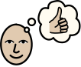  Positive | Something that is good or wanted.
 |  | Quality | A characteristic of something or someone.
 |  | 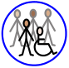  Community | A group of people who have the same things in common such as interests or where they live.
 |  | 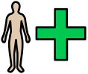  Physical health | The normal functioning of the body.
 |  | 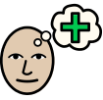  Mental health | A person’s emotional wellbeing.
 |  | 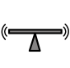  Balanced | Equal proportions of something, not too much or too little.
 |  | 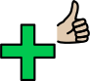  Healthy | Showing good mental and physical wellbeing.

