` ``````````````````````````````````````````````````````````````````11``````````````````````````````````````````````````````````````````````````` ``` ` ` ` ` ` `` ` ````````````````````````16 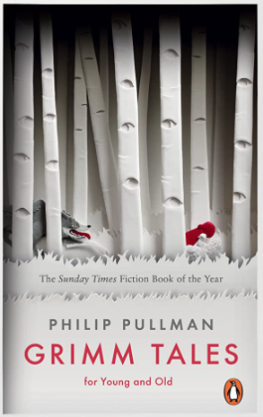
Revisited Skills:
- Using relative clauses to add additional detail to writing
- Writing consistently in the correct tense.
- Editing and improving my work.
- Accurately punctuating my writing to ensure it can be read cohesively.
- Orally create and retell a story with appropriate intonation and actions.
New Skills:
- Creating a sustained setting description using expanded noun phrases.
- Selecting appropriate vocabulary for the purpose of writing.
- Using adverbials and prepositions to ensure my writing in linked in a cohesive manner.
- Using structural and grammatical features of a crime report.
- Using and identifying conventions of a fairy tale.
Audience: Chief of Police
Form: Crime Report
Purpose: To formally inform and report about a crime that has been committed.
Tier 3 Vocabulary:
Suspect victim perpetrator witnesses heist investigation article offence forensic(s)
Tier 2 Vocabulary:
Accompany according apparent bruise (un)conscious desperate determined equipped especially familiar frequently immediately individual mischievous

Theme: consequences, choices, fantasy
Related texts:
Clockwork – Philip Pullman
The Owls Service – Alan Garner
The Firework Maker’s Daughter – Philip Pullman

