Year 4 – RE- Good and Evil- Hinduism
What should I already know? | What am I going to learn in this unit? | Vocabulary I need to know
Knowledge  - Know the meaning of the concept of ‘Creation’- the Christian story of Temptation (eating from the tree of life)  - Examples of ‘Good’ and ‘Evil’ in your own life- books, films etc  - Know the meaning of the concepts of ‘Celebration’ and ‘Ceremony’ (year 3).  Skills  - I can ask questions to understand the meaning of a concept.  - I can identify how a concept relates to a particular faith and describe ways in which this is shown.  - I can describe the feelings that are important to me and explain why. | Inquire  - I can identify and provide an example of how I have experienced good and evil.  - I can ask questions to understand the meaning of the concept of good and evil.  Contextualise  - I can identify and explain how good and evil features in Hindu stories.  - I can understand the importance of the concept of good and evil in Hindu religion and provide an example.  Evaluate  - I can recognise and describe accurately how good over evil is important to the Hindu faith.  - I can explore and explain my opinion as to how and why good and evil is shown in the Hindu celebration of Holi.  Communicate  - I can give an example of good/ evil in my own life and in the world around me.  - I can give opinions as to what I think makes good/ evil and explain why.  Apply  - I can describe simple examples of how good comes out of evil in my life and the world around me.  - I can identify some differences the concept of good and evil makes to the lives of religious people and myself. | Good Doing what is right and having qualities that are desired.  Evil 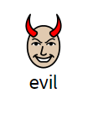 anything very wrong or bad that hurts people or animals and is done without concern for the pain of others; wickedness.  Holi A Hindu festival celebrated as the festival of colour, love and spring.  Consequence 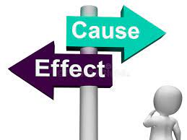 The effect or outcome of something.  Resolution a solution or end to an argument or other conflict.

