Year 5 (RE) Knowledge Organiser – Autumn 1 Belonging
What should I already know? | What am I going to learn in this unit? | Vocabulary I need to know
Knowledge  - Know the concept of ‘Being part of something’ (year 2).  - Know the meaning of the concept of ‘Symbol’ (year 4).  - Awareness of the idea of belonging within day to day life  - Know the concept of ‘Symbol’ (year 4).  Skills  - I can ask question to understand the meaning of a concept in my own life and the lives of those around me.  - I can describe and explain the concept and how these are important aspects of the faith | Communicate  - I can share my own experiences of belonging and give some examples of things that show I belong.  - I can explain some of the challenges I have faced in experiencing a sense of belonging as well as some positives.  Apply  - I can begin to explore the significance of the concept and the implications if it didn’t exist.  - I can explain how the concept of Belonging features in my own life with examples.  Inquire  - I can ask questions to understand the meaning of concepts.  - I can use examples and build on others’ ideas to help define the meaning of belonging.  Contextualise  - I can describe some practical things which a Muslim which creates a sense of belonging to the wider Islamic community.  - I can identify how I might behave in a similar way to those of a believer. I can draw similarities and differences to the values we hold.  Evaluate  - I can make comparisons between a Muslims understanding/ sense of belonging and explain the significance of different viewpoints.  - I can recognise that some features are different in the same religion and explain why this might be. | Belonging If someone belongs to a a particular group, they are a member of that group.  Community The people who live or worship in a particular place or area.  Sacrifice Giving up something for the sake of someone else.  Mosque A building where Muslims go to worship.  Eid UL Adah 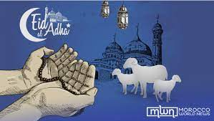 A Muslim festival of sacrifice.

